1 .Create project in java perspective .

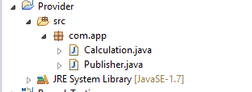

**package** com.app;

**import** javax.jws.WebMethod;

**import** javax.jws.WebService;

@WebService

**public** **class** Calculation {

@WebMethod

**public** **int** doSum(**int** x,**int** y){

**return** x+y;

}

}

….....................

**package** com.app;

**import** javax.xml.ws.Endpoint;

**public** **class** Publisher {

**public** **static** **void** main(String[] args) {

//where to publish

String address="http://localhost:9999/sample";

//what to publish

Calculation calOb=**new** Calculation();

Endpoint.*publish*(address, calOb);

System.***out***.println("done");

}

}

………………………..

Type url :

<http://localhost:9999/sample>

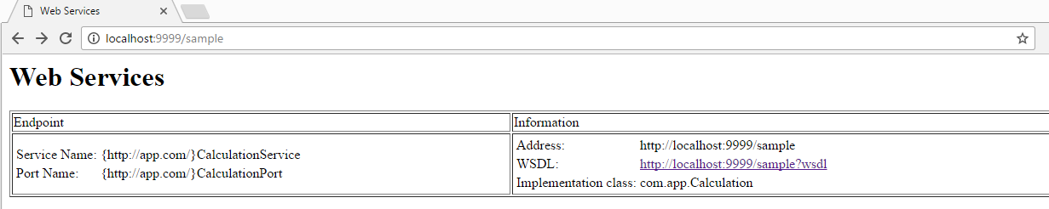

<http://localhost:9999/sample?wsdl>

the following xml will be displayed on web page.

This XML file does not appear to have any style information associated with it. The document tree is shown below.

<!--

Published by JAX-WS RI at http://jax-ws.dev.java.net. RI's version is JAX-WS RI 2.2.4-b01.

-->

<!--

Generated by JAX-WS RI at http://jax-ws.dev.java.net. RI's version is JAX-WS RI 2.2.4-b01.

-->

<definitions xmlns:wsu="http://docs.oasis-open.org/wss/2004/01/oasis-200401-wss-wssecurity-utility-1.0.xsd" xmlns:wsp="http://www.w3.org/ns/ws-policy"xmlns:wsp1_2="http://schemas.xmlsoap.org/ws/2004/09/policy" xmlns:wsam="http://www.w3.org/2007/05/addressing/metadata" xmlns:soap="http://schemas.xmlsoap.org/wsdl/soap/"xmlns:tns="http://app.com/" xmlns:xsd="http://www.w3.org/2001/XMLSchema" xmlns="http://schemas.xmlsoap.org/wsdl/" targetNamespace="http://app.com/"name="CalculationService">

<types>

<xsd:schema>

<xsd:import namespace="http://app.com/" schemaLocation="http://localhost:9999/sample?xsd=1"/>

</xsd:schema>

</types>

<message name="doSum">

<part name="parameters" element="tns:doSum"/>

</message>

<message name="doSumResponse">

<part name="parameters" element="tns:doSumResponse"/>

</message>

<portType name="Calculation">

<operation name="doSum">

<input wsam:Action="http://app.com/Calculation/doSumRequest" message="tns:doSum"/>

<output wsam:Action="http://app.com/Calculation/doSumResponse" message="tns:doSumResponse"/>

</operation>

</portType>

<binding name="CalculationPortBinding" type="tns:Calculation">

<soap:binding transport="http://schemas.xmlsoap.org/soap/http" style="document"/>

<operation name="doSum">

<soap:operation soapAction=""/>

<input>

<soap:body use="literal"/>

</input>

<output>

<soap:body use="literal"/>

</output>

</operation>

</binding>

<service name="CalculationService">

<port name="CalculationPort" binding="tns:CalculationPortBinding">

<soap:address location="http://localhost:9999/sample"/>

</port>

</service>

</definitions>

Consuming the service :

Create a project

Ex : ConsumeService

Find the location of your program

Rightclick on src ----🡪 properties ---🡪 copy the path ----🡪

Opem cmd prompt ----------- >go to your current working directory

Type : wsipmort –keep url :

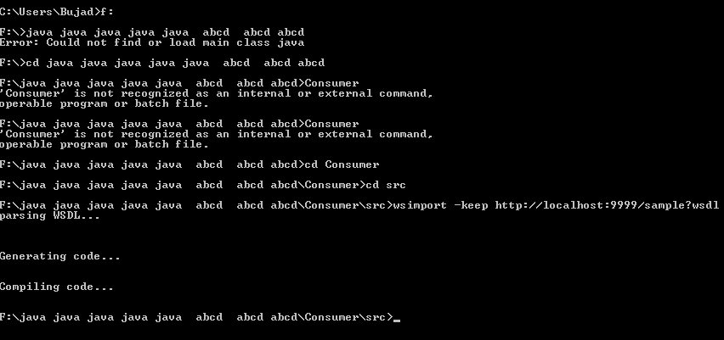

Refresh the src

We will find some stub folder (prorammes)

------- > Create a consumer class

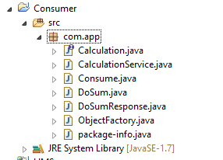

**package** com.app;

**public** **class** Consume {

**public** **static** **void** main(String[] args) {

//step 1: create Object for service

CalculationService cs=**new** CalculationService();

//step 2: create object for PortType. use get[PortName]() method

Calculation c=cs.getCalculationPort();

//step 3: call operation, pass parameters and get Return Type

**int** res=c.doSum(10, 200);

//display result

System.***out***.println("Sum result from service is:"+res);

}

}